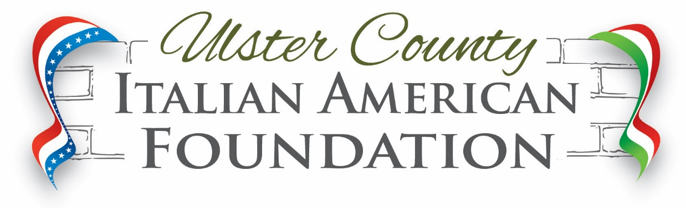

**EDUCATIONAL AWARDS**

**Deadline: April 30, 2025**

**Criteria Check-Off List**

* **Must be from Italian-American Descent (or from a family of Italian-American Descent)**
* **Academic Excellence (80% or higher)**
* **Service to School and Community**
* **Must be planning to attend a 2 or 4 yr. institution in Fall of this year**
* **Complete and return UCIAF Application Form**
* **250-500 word typed essay – “What my Italian/American Ancestry means to me” including how your Italian-American heritage has impacted your life**
* **3 letters of recommendation (two from school personnel and one from a community member)**
* **Students must attend a high school in Ulster County and be enrolled as a full time student**
* **An original High School transcript must be provided in a sealed envelope.**
* **Award Winners will be asked to read their essay at the Annual Awards Dinner in June**

Our Mission

We are dedicated to preserving, promoting and celebrating the rich culture Italian Americans share in Ulster County. We achieve our goals through outstanding cultural programs, language classes, educational lectures, monthly dinners and community support. We raise funds to provide educational awards to students, contributions to not-for-profit organizations and to those individuals in need of hardship assistance. To work with and partner with existing Italian organizations within Ulster County.

**Award applications are available online at** [**www.uciaf.org**](http://www.uciaf.org) **and can be mailed to:**

**Anna Brett/UCIAF Awards Chair**

**57 Clifton Avenue**

**Kingston, N.Y. 12401**

**845-339-5403**